# Day 2 - Deploy and Secure the VM

1. **Deploy the VM.**
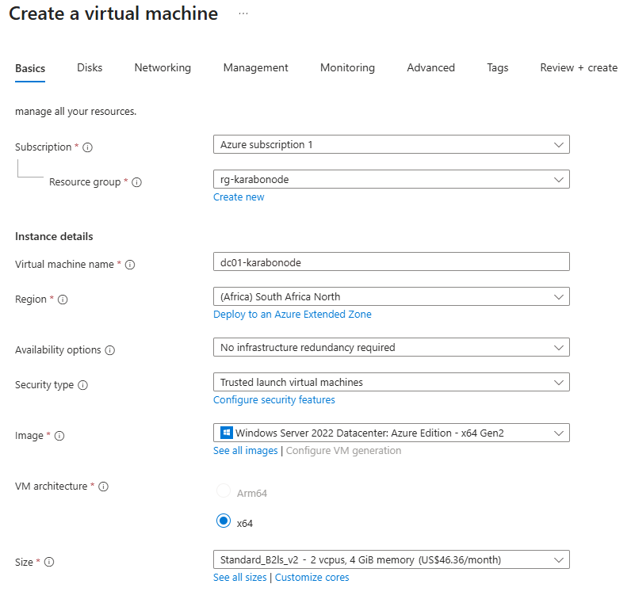
**Disks tab**

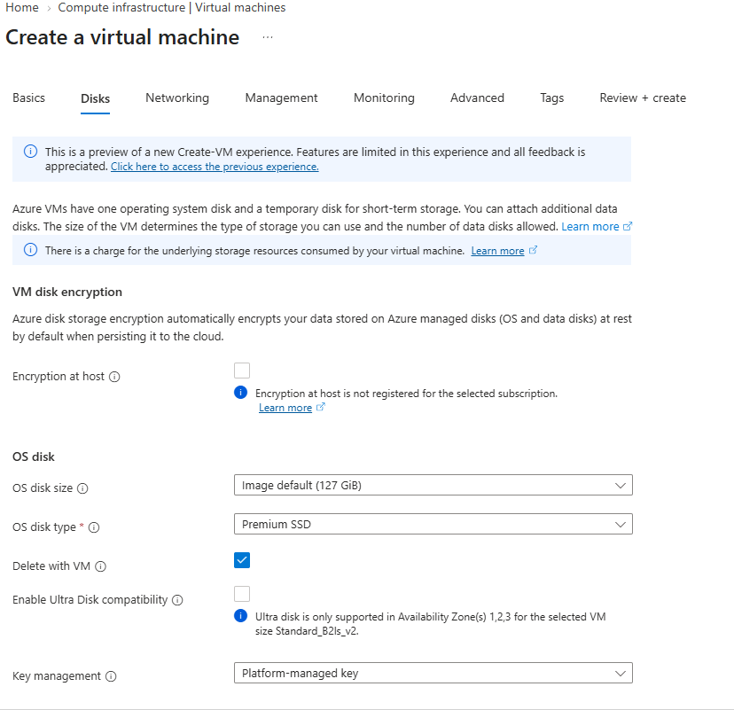
32 GiB, Standard SSD — this becomes the `F:` drive for the AD database/logs/SYSVO
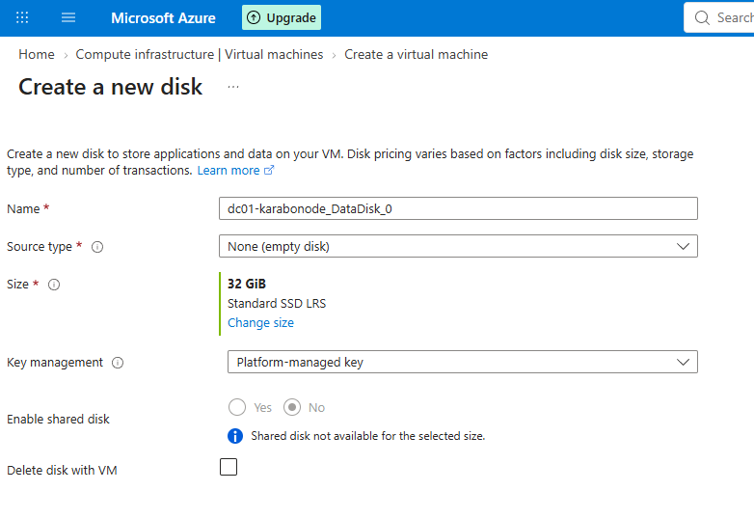
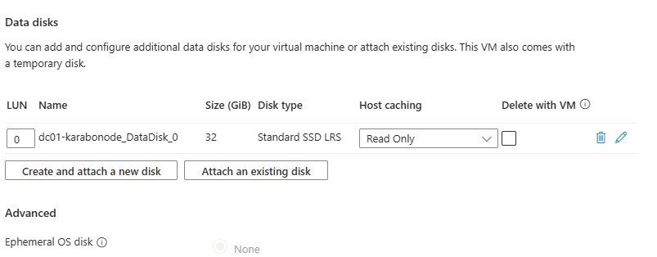
*Networking tab**
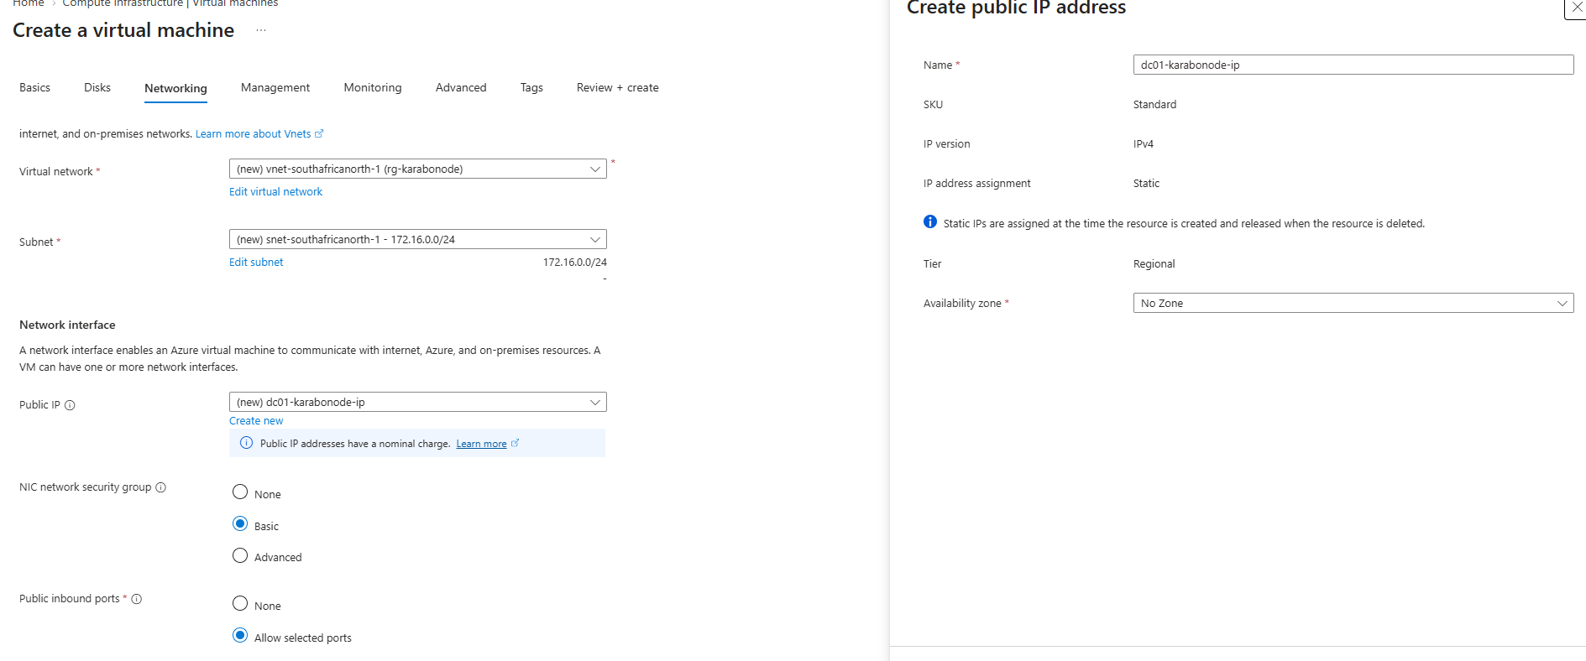
**Lock down the NSG.**
Need to lock the NSG to only allow my IP to connect via rdp
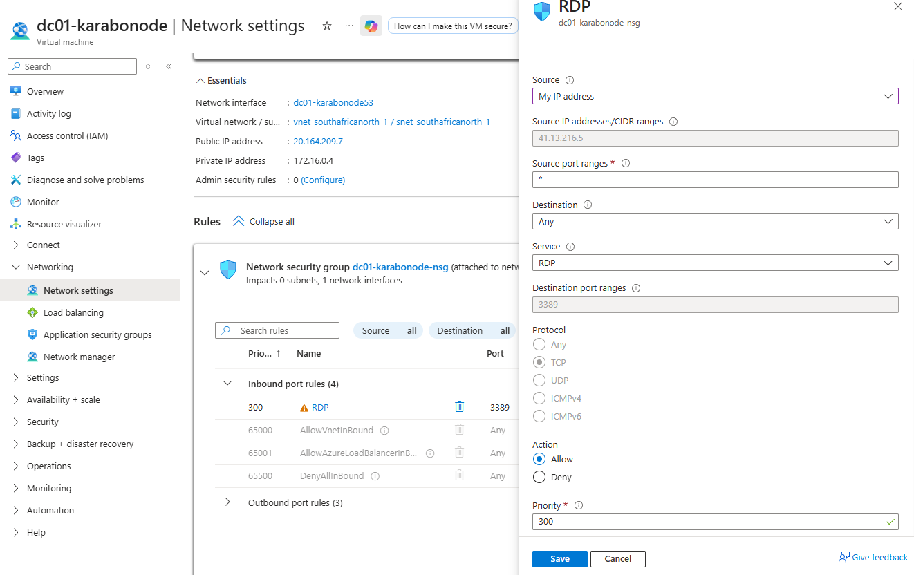

Connect to using RDP
mstsc /v:20.164.209.7
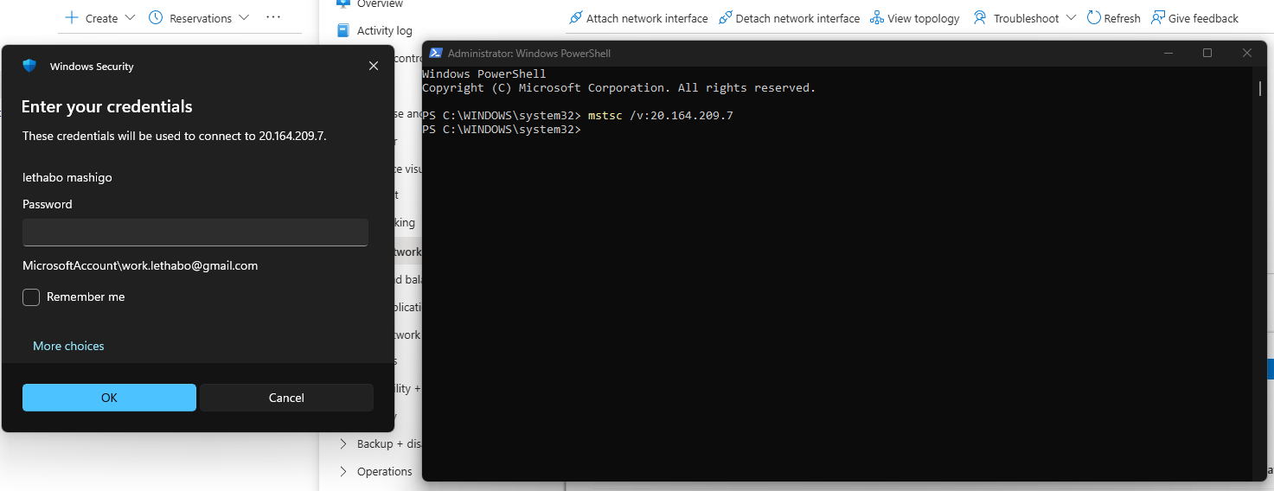
Login Succesful:
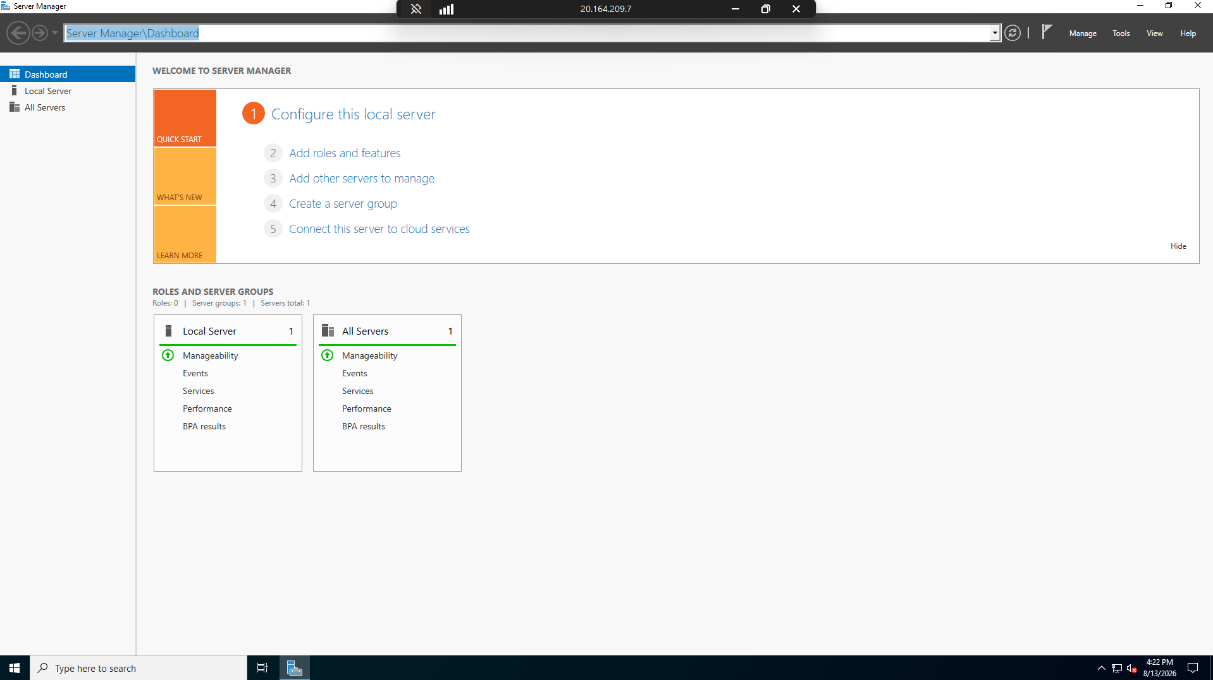

## Why this matters
Mirrors real-world hardening - exposed RDP is one of the most common breach entry points.

## Skills covered
VM provisioning (image/size selection), attaching purpose-built data disks, NSG hardening to a single source IP, RDP-based remote administration.

Deallocate other resources for the rest of the day and take a break:
